Article Title (Times New Roman; Size-16; Line Spacing: single spacing; Paragraph Spacing: Above paragraph-10pt, Below paragraph-10pt)
^{1*}First Author, ²Second Author, ³Third Author (font 12, Times New Romans, Paragraph spacing: Above paragraph-0pt, below paragraph-0pt), single spaced)
^{1*}Author’s Name (Orcid Number) (To Register: https://orcid.org/)
Department, College/University Name, Country
*Corresponding Author’s Email:
²Second Author’s Name (Orcid Number)
Department, College/University Name, Country

Abstract (Capitalize each word, Font 12, single-spaced, bold) (Maximum 350 words)
Purpose: Cleary outline the aim of the study
For example: The goal of this study is to look at Dubai's history of innovation and excellence over the last 30 years and to investigate the impact of these characteristics on the city's economic progress. The study intends to answer a series of research questions about perceptions of Dubai's level of innovation and excellence, the most inventive industries and sectors, and the significance of these qualities for the city's future economic success.
Methodology: Research design, sampling technique, sample size, data collection procedure and statistical analysis.
For example: The study adopted a descriptive research design. Census was used to select a total of 109 projects and respondents from the various projects identified in the study area. The study involved the use of questionnaire method to collect data. . Secondary data was collected by a study of records and documents in various departments in the firm involved in public projects management. Qualitative data was analyzed by use of content analysis. Quantitative data was analyzed by employing descriptive statistics and inferential analysis using statistical package for social science (SPSS) version 22 and excel. Tables and Figures were also used to present the data.
Findings: Clearly outline the results of the study
For example: The study revealed from the analysis that product innovation has a statistically positive relationship with customer satisfaction (r = .847; P-value < 0.05) and between process innovation and customer retention (r = .813; P-value < 0.05). Also revealed was technological innovation has a statistically significant influence on competitive advantage (r = .769; P-value < 0.05) and that marketing innovation has a statistically significant influence on brand awareness (r = .790; P-value < 0.05). It was concluded that innovation practices have a significant relationship with performance of SMEs.
Unique Contribution to Theory, Practice and Policy: Theory (which theory or model informed your study?, how was it validated in the study?), Practice( Recommendations to the practitioners) , Policy(Recommendation to the policy makers)
For Example: Utilizing the Public Interest Economic Regulation Theory (PIERT), the Q Theory of Housing Investment, and the Theory of Distributive Justice, the research explores the interplay between government regulations, market forces, and social equity in the context of affordable housing. To address challenges, policymakers should strengthen regulatory frameworks, enhance financial policies, and promote diverse housing models. Public awareness campaigns are vital. Recommendations include tailored financial products and inclusive strategies to meet the varied needs of the population. These measures aim to create an enabling environment for accessible and sustainable housing in Nairobi County, benefiting both existing and aspiring homeowners.
Keywords: Please include 3-5 keywords (Separated by commas, italicized, Capitalize each word)
For example: Capacity, Culture, Performance, Sourcing, Posture, Technology
2. Body
This should have 5 sections
1. INTRODUCTION (Font size of heading 12 Bold in Capital Letters, Times New Roman, single spacing, Paragraph spacing: Above paragraph-5pt, below paragraph-5pt))
Introduction should be given in this section, it cover general introduction and statement of the problem. Should be font 12, Times New Romans, single spaced and in block format. The subheading should be capitalize each word.
For Example:
General Introduction (Font size of heading 12 Bold in Title case, Times New Roman, single spacing, Paragraph spacing: Above paragraph-5pt, below paragraph-5pt)
Supply chain alignment is the process of integrating the activities in a supply chain framework to incorporate all the main stakeholders ranging from customers, employees and the suppliers (Skipworth & Julien, 2015). The practice of determining all lifespan expenses that result from inventory ownership is known as inventory ownership analysis. These can include significant expenditures for installing, deploying, running, and maintaining the same inventory in addition to the obvious purchasing prices. Inventory ownership analysis often finds large differences between purchase price and total life cycle costs (Mokadem, 2016). According to Milligan (2012), inventory ownership analysis involves continuous delivery of materials, component or subassemblies in a supply chain is very different and much more demanding than the total cost of ownership of equipment (for example computers and printers). In these cases, inventory ownership analysis is essentially a lifecycle cost computation adding to the acquisition cost of the equipment, the expected amount of operation and maintenance costs in order to compare better different alternatives.
Statement of the Problem (Font size of heading 12 Bold in Title case, Times New Roman, single spacing, Paragraph spacing: Above paragraph-5pt, below paragraph-5pt
Continual improvement and alignment to the broader organizational goals are essential to the sustainability and overall success of the firm in a competitive environment, despite the complexity and length of supply chains for manufacturing firms. However, it is uncommon to achieve this required optimality in alignment and performance (World Bank, 2013). Inventory ownership analysis as one of the components of supply chain alignment is therefore paramount to any organization since it leads to improved product design, quality and cost consciousness, which means an improvement in the performance of a firm.
Due to a volatile operating climate and misalignment of their different supply chains, large-scale manufacturers operating in Kenya have been regularly recording stagnation and declining earnings for the previous five years. Public, professionals, and other stakeholders are increasingly complaining about how well manufacturing companies are performing (Skipworth & Julien, 2015). Several studies have shown the need for properly managed inventory and aligned supply chain processes through inventory ownership analysis in order to enhance the performance of the manufacturing industry (Kaplan & Norton, 2014; Attia, 2015; Mokadem, 2016). These studies, however, have focused on different contexts, and their findings may not be generalized to manufacturing sector in Kenya. This study therefore sought to assess the role played by inventory ownership analysis on the performance of manufacturing industry in Kenya.
2. LITERATURE REVIEW (Font size of heading 12 Bold in Capital Letters, Times New Roman, Single spacing, Paragraph spacing: Above paragraph-5pt, below paragraph-5pt))
Literature Review should be given in this section. This should have conceptual framework, theoretical framework, Conceptual framework empirical review and research gaps. All the subheadings in this section should be in font size 12 Bold, Times New Roman, single spaced. The subheading should be capitalize each word.
Theoretical Framework (Font size of heading 12 Bold in Title case, Times New Roman Paragraph spacing: Above paragraph-5pt, below paragraph-5pt
For Example:
Ladder of Participation Model (Font size of heading 12 Bold in Title case, Times New Roman, single spacing, Paragraph spacing: Above paragraph-5pt, below paragraph-5pt
The model Ladder of Participation by Arnstein (1969) was first employed in the concept of community participation. Arnstein’s framework suggests there are various levels of participation and engagement in programmes, projects and activity decision making processes. For example, the level of ‘informing’ may present significant differences in the quality, type and detail of information conveyed. The ladder signifies more control being better than less control, yet in practice, increased control is not likely desired by the community. Moreover, control should be increased alongside the necessary support so as not to result in failure.
The importance of this model comes from the recognition of the existence of different participants and their different levels of participation. These range from manipulation, through consultation and genuine participation. This determines the levels of partnership with citizens. Practically however, participation levels often present a complex continuum instead of the desired or expected simple series of steps. This model presents eight levels and types of stakeholder participation including manipulation and therapy which is considered non- participative, the third is informing- which is one way flow of information.
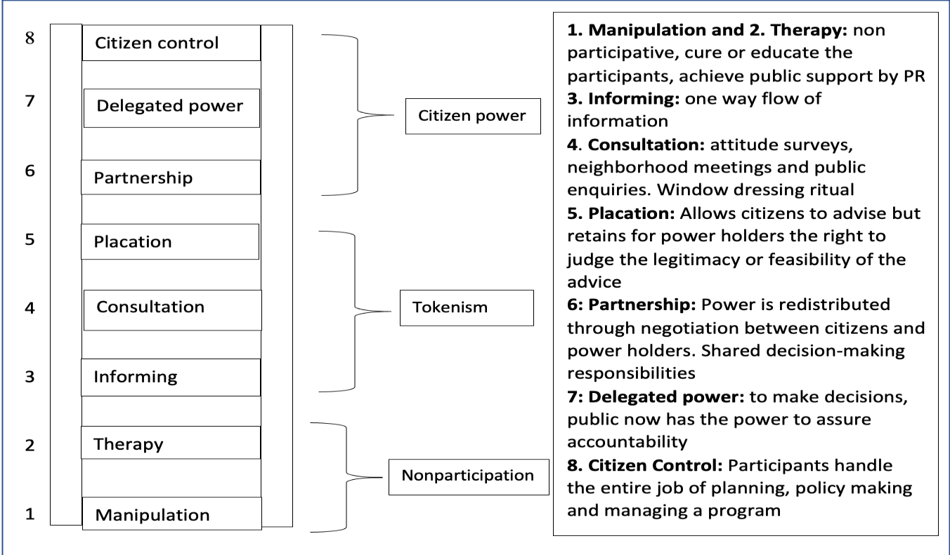
Figure 1: The Ladder of Citizen Participation Model
Conceptual Framework
Devolved Enterprise Funding Household welfare

Receipt of Youth Enterprise Fund
- Amount received by household

Receipt of Women Enterprise Fund
- Amount received by household

Uwezo Funds
- Amount received by household

- Food security
- Health status
- Education status
- Poverty status

Figure 1: Conceptual Framework
Access to devolved enterprise funds is expected to increase the level of household welfare through the education and poverty alleviation, specifically through receipt of Women Enterprise Fund, receipt of Youth Enterprise Fund and Uwezo Funds. With access to microcredit, an investment in company assets and self-employment income grows significantly. The increase in employment income may increase the probability of household expenditure income and accumulation of assets resulting in positive changes in household welfare.
Empirical Review (Font size of heading 12 Bold in Title case, Times New Roman, single spacing, Paragraph spacing: Above paragraph-5pt, below paragraph-5pt
Black and White (2003) compared the value relevance of earnings relative to book value of equity in Germany, Japan and the US owing to the size of their capital markets and differences in accounting systems and institutional structures. They found that book values are more value relevant than earnings in Germany and Japan while earnings are more value relevant in the US, because capital providers in Germany and Japan are more concerned with balance sheet measures such as liquidity. The book value of equity is more value-relevant than earnings, particularly in Germany, with mixed results for Japan. In the US, positive earnings are more value relevant than book value of equity, but not negative earnings. Therefore, the value relevance of financial information is influence by the accounting and institutional structures. Ultimately, these are influenced by the national culture of respective countries (Kwok and Tadesse, 2006).
Pervan and Bartulović (2013) examined the value relevance of accounting information from five stock exchange involving 97 corporations from South Eastern European countries for the period 2005–2010. Results of conducted research have shown that accounting information, i.e. book value and earnings are value relevant on all the observed capital markets. The analysis of regression and determination coefficients has shown that on the observed capital markets value relevance of book value is higher than value relevance of earnings.
Research Gaps (Font size of heading 12 Bold in Title case, Times New Roman, single spacing, Paragraph spacing: Above paragraph-5pt, below paragraph-5pt)
A notable drawback in the study conducted by (UN Environment , 2015) is the limited emphasis on quantifying the impact of low-carbon alternatives in addressing climate change, a gap that exists despite advancements in providing such alternatives. Previous studies, including those by (Graziano, 2015) (David, 2018), and (Adwek, 2019), have made strides in exploring low-carbon options, but few have delved into a quantitative assessment of their actual impact. The scarcity of supporting data for the methods proposed in this context, as highlighted by (van der Kam, 2018), contributes to the overall lack of comprehensive information regarding progress toward achieving the 1.5°C targets.
Consequently, there exists a knowledge gap concerning the potential of Small Home Systems as a means of climate change mitigation, emphasizing the critical need to examine the success of already installed systems to gain insights into their greenhouse gas emissions reduction capabilities.
METHODOLOGY (Font size of heading 12 Bold in Capital Letters, Times New Roman, single spacing Paragraph spacing: Above paragraph-5pt, below paragraph-5pt)
Details about methodology should be given in this section. Font Size 12, Times New Roman, single spaced. All the subheadings in this section should be in font size 12 Bold, Times New Roman, single spaced. The subheading should be capitalize each word. This section should have the following: Research design, sampling technique, sample size, data collection procedure and statistical analysis.
For Example:
The study adopted positivism philosophy approach and descriptive research design was used. The study focused on all the thirteen (13) MFBs regulated by the CBK. The research used purposive sampling and the sampling techniques were chosen because of the characteristic of the population and the study requires the senior managers who are experts in the work they are doing. The respondents were the five managers from each MFB totaling to 65 these are the Chief Executive Officer, finance managers, Business development manager, credit officers and operations manager. Data collection was done by acquiring data from primary sources and for this study data was collected from the microfinance banks institutions. The raw data was acquired from the issuing of the questionnaires. Primary data was collected using questionnaire and a Statistical Package for Social Sciences (SPSS) software was used to analyze data. Data was coded before being used by SPSS. Descriptive statistics (frequencies, mean scores, and standard deviations) were used to describe the characteristics of the variables. Descriptive statistics provide the basic features of the data collected. Inferential statistics was used to conclude the findings of test done on a population by taking a sample of an information from the large population. The inferential statistic techniques were used to measure the significance of the relationship while the bivariate regression was employed to find out whether agency banking had a positive correlation with performance of the MFBs. The results of the study were presented using tables and figures.
RESULTS (Font size of heading 12 Bold in Capital Letters, Times New Roman,single spacing, Paragraph spacing: Above paragraph-5pt, below paragraph-5pt)
In this section please present the results including tables, figures, numbers and graphs (if any). Font Size 12, Times New Roman, single spaced. All the subheadings in this section should be in font size 12 Bold, Times New Roman, single spaced. The subheading should be capitalize each word. Place illustrations (figures, tables, drawings, and photographs) throughout the paper at the places where they are first discussed in the text, rather than at the end of the paper. Number illustrations sequentially (but number tables separately). Place the illustration numbers and caption under the illustration in 12 pt font. (The tables and figures should not be hanging i.e don’t close to the other page and should be within the margins of the paper). Label the figures as Figure (1, 2,3,…..), name the figure and placed it below the figure (title case and italicize). If your figure has two parts, include the labels “(a)” and “(b)”, therefore will be named as 1(a) and 1(b). Place table titles above the tables and should be numbered as table 1,2,3…. It should use font 12, Times New Roman, single spaced and title case. The tables should be in APA format.
For example:
Descriptive Analysis for Mobile Banking (Font size of heading 12 Bold in Title case, Times New Roman, single spacing, Paragraph spacing: Above paragraph-5pt, below paragraph-5pt)
The study examined the effect of mobile banking on performance of microfinance banks. The objective was examined by the use of the statements on the questionnaire. The statements were on whether the customers were able to deposit cash, withdraw cash, pay bills, transfer funds, enquire balance and loan application. The respondents were asked to indicate whether they agree or disagree with the statement. After data collection the questionnaires were coded and analyzed using SPSS. Frequencies of the various outcomes were drawn in percentages from the sample and then presented in Table 1 below.
Table 1: Descriptive Analysis for Mobile Banking
Statement | D  % | NS  % | A  % | SA  % | Mean | Std Dev
Customers can be able to deposit cash using their mobile phone |  |  | 16.7 | 83.3 | 4.85 | 0.360
Customers are able to withdraw cash with their mobile phone |  |  | 21.7 | 78.3 | 4.78 | 0.415
The customers can be able to transfer money using mobile phone |  |  | 35.0 | 65.0 | 4.60 | 0.616
The customers are able to use mobile telephone to pay bills | 8.3 | 13.3 | 28.3 | 50.0 | 4.17 | 1.060
The customers are able to enquire their balances on mobile phone |  |  | 18.3 | 81.7 | 4.82 | 0.390
The customers can apply for loan using their telephone | 43.3 | 8.3 | 20.0 | 28.3 | 3.13 | 1.546
Overall |  |  |  |  | 4.39 | 0.851
Scree Plot for Mobile Banking (Font size of heading 12 Bold in Title case, Times New Roman, single spacing, Paragraph spacing: Above paragraph-5pt, below paragraph-5pt)
The Figure 2 presents a scree plot for mobile banking. The results in Figure 4.6 shows the scree plot with the extraction of eigenvalues for mobile banking. The downward curve indicates the two factors which had eigenvalues greater than 1. This curve shows the variance explained with a break point of two items with eigenvalue and all the six parameters in the variable were included for the regression analysis.
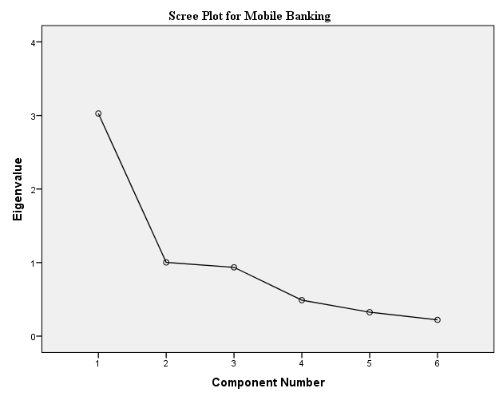
Figure 2: Scree Plot for Mobile Banking (Font size of heading 12 Bold in Title case, Times New Roman, Italicized, Paragraph spacing: Above paragraph-5pt, below paragraph-5pt
CONCLUSION AND RECOMMENDATIONS (Font size of heading 12 Bold in Capital Letters, Times New Roman, Single spacing, Paragraph spacing: Above paragraph-5pt, below paragraph-5pt)
This section should be Font Size 12, Times New Roman, single spaced. Conclusion (Briefly include the conclusion of the study) and recommendations (This should cover the theory aspect, practice and policy).
Summary (Font size of heading 12 Bold in Title case, Times New Roman, single spacing, Paragraph spacing: Above paragraph-5pt, below paragraph-5pt)
The study established that stakeholder involvement affect completion of government funded agricultural projects in arid and semi-arid areas in Kenya. The study findings in indicated to a great extent that he management consults with the stakeholders on the implementation of the project activities. The management involves the project team in the project strategy planning and formulation. The management communicates the project expectations to all its stakeholders. The management obeys the decision developed by the stakeholders and adheres to the provisions of project rules and regulations in its operations. The organization meets the legal requirements to ensure that there is streamlined project implementation. The management consults with the stakeholders on the strategy implementation.
Conclusions (Font size of heading 12 Bold in Title case, Times New Roman, Single spacing, Paragraph spacing: Above paragraph-5pt, below paragraph-5pt)
The study concludes that stakeholder involvement is the first important factor that influence completion of government funded agricultural projects in arid and semi-arid areas The regression coefficients of the study show that stakeholder involvement has a significant influence on completion of government funded agricultural projects in arid and semi-arid areas. This shows that stakeholder involvement has a positive influence on completion of government funded agricultural projects in arid and semi-arid areas in the study area.
Recommendations (Font size of heading 12 Bold in Title case, Times New Roman, single spacing, Paragraph spacing: Above paragraph-5pt, below paragraph-5pt)
The study therefore recommends that the health sector in Kenya should work towards strengthening the frameworks for stakeholder engagement in the health-related projects if sustainability of the projects must be attained. There is great need to review and ensure stakeholder relationship management, stakeholder participation in the decision making of key activities as well as ensure avenues to enable stakeholders actively participate in project activities along the entire project life cycle. The study recommends stakeholder mapping to be done based on meritocracy. The study recommends that the legal and regulatory framework around the stakeholder engagement should be strengthened to ensure compliance.
Based on the summary and conclusions above, the study recommends that the health sector unit that is concerned with implementing donor funded projects should review the instruments of leadership to ensure proper networking and collaborating in projects, and that leaders facilitate coaching to all team members. Communication and more specifically timely feedback came out as a key contributor to the project process execution success.
Based on the empirical evidence of this research, the study recommends that policy makers, the Republic of Kenya, donors, and other interested stakeholders should design policies that support all-inclusive stakeholder engagement.
REFERENCES (Font size of heading 12 Bold in Capital Letters, Times New Roman, single spacing, Paragraph spacing: Above paragraph-5pt, below paragraph-5pt)
For references please use Font Size 12, Times New Roman, single spaced. This should be in APA format. Here are some examples of references.
Abadi, M. . (2023). Role of Culture on Leadership and Governance in Saudi Arabia. International Journal of Leadership and Governance, 3(1), 24–35. https://doi.org/10.47604/ijlg.1926
Lamprinidis, L. (2023 b). Challenges of the Social Economy Action Plan for Greece in the Light of the Socially Responsible Public Procurement. Journal of Public Policy and Administration, 8(2), 55–66. https://doi.org/10.47604/jppa.1843

Omowumi, A., Elizabeth, A., & Beloved, A. . (2023). Effective Health Communication and Required Competencies - the Case of Race and Gender Blindness in Major Online Health Information Sites. International Journal of Communication and Public Relation, 8(3), 28–35. https://doi.org/10.47604/ijcpr.2038
Sloane, B. C., & Zimmer, C. G. (1993). The power of peer health education. Journal of American College Health, 41(6), 241-245.
4. Page Size and Layout
Set your page as A4, Margins (normal)
Top (1) Bottom (1)
Left (1) Right (1)

